

App_Imageviewer2: How to generate the flash image

**Version 1.0**

**Issue Date: 2019-01-14s**

**Table of Contents**

1 Introduction 3

1.1 Overview 3

1.2 Scope 3

1.3 Compatibility 3

2 Display image on EVE platform with flash image 4

2.1 Generating the flash image 4

2.1.1 List of images used by App_Imageviewer2 4

2.1.2 Convert images into ASTC format 4

2.1.3 Generate flash image with converted images 8

2.2 Store the generated flash image inside flash memory on EVE platform 13

2.3 Display images using generated flash image 14

3 Contact Information 16

Appendix A– References 17

Document References 17

Acronyms and Abbreviations 17

Appendix B – List of Tables & Figures 18

Table of Figures 18

Table of Tables 18

Appendix C– Revision History 19

# Introduction

## Overview

The demo application App_Imageviewer2 uses several images to display on the LCD, these images are stored on the flash memory of the EVE platform.

This document provide information on how to create the flash image and use it to display images on the EVE platform.

## Scope

The scope of this application note is to explain steps to create the flash image for EVE platform, and how App_Imageviewer2 use the created flash image to display images on EVE platform.

## Compatibility

The method provided is primarily targeted for the App_Imageviewer2 application, this application should only be run on BT815 and BT816 SoC with flash memory attached on the board.

Tool EVE Asset Builder used in this document is at version 0.3.2. It is available at https://brtchip.com/eve-toolchains

# Display image on EVE platform with flash image

The App_Imageviewer2 uses several images in ASTC format, they are converted from JPG images.

All the ASTC images are combined into one flash image.

## Generating the flash image

### List of images used by App_Imageviewer2

Below are list of images using by App_Imageviewer2, they are located in UI_Assets folder:

|  |  |  |  |
| --- | --- | --- | --- |
| Name | Image size | Name | Image size |
| F0.jpg | 120x60 | S_F0.jpg | 800x480 |
| F1.jpg | 120x60 | S_F1.jpg | 800x480 |
| F2.jpg | 120x60 | S_F2.jpg | 800x480 |
| F3.jpg | 120x60 | S_F3.jpg | 800x480 |
| F4.jpg | 120x60 | S_F4.jpg | 800x480 |
| F5.jpg | 120x60 | S_F5.jpg | 800x480 |
| F6.jpg | 120x60 | S_F6.jpg | 800x480 |
| F7.jpg | 120x60 | S_F7.jpg | 800x480 |
| F8.jpg | 120x60 | S_F8.jpg | 800x480 |
| F9.jpg | 120x60 | S_F9.jpg | 800x480 |
| F10.jpg | 120x60 | S_F10.jpg | 800x480 |
| F11.jpg | 120x60 | S_F11.jpg | 800x480 |
| F12.jpg | 120x60 | S_F12.jpg | 800x480 |
| F13.jpg | 120x60 | S_F13.jpg | 800x480 |
| F14.jpg | 120x60 | S_F14.jpg | 800x480 |
| F15.jpg | 120x60 | S_F15.jpg | 800x480 |
| F16.jpg | 120x60 | S_F16.jpg | 800x480 |
| F17.jpg | 120x60 | S_F17.jpg | 800x480 |
| F18.jpg | 120x60 | S_F18.jpg | 800x480 |
| F19.jpg | 120x60 | S_F19.jpg | 800x480 |

Table 1: Image list

### Convert images into ASTC format

The purpose of this step is to compress the image into a smaller size. This can be done with EAB tool. The steps are described as below:

* Start EAB tool and select tab “Image converter”:

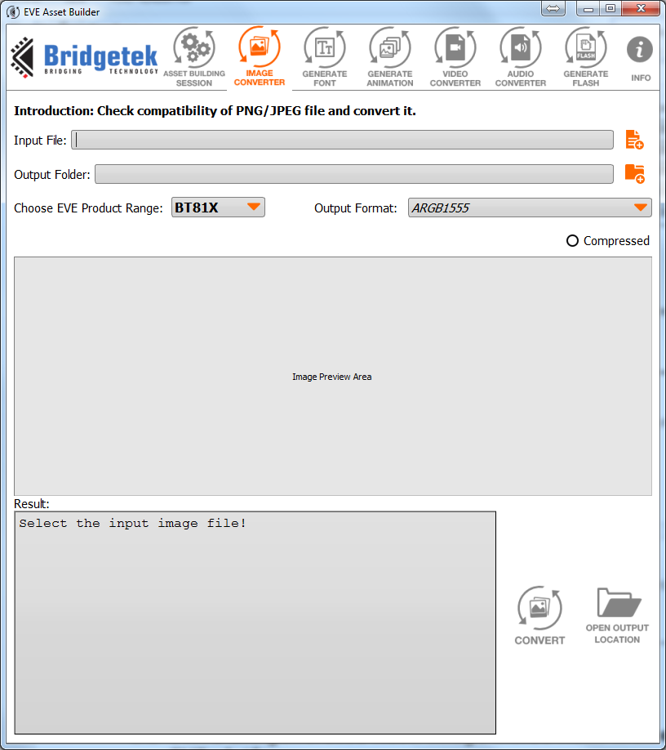

Figure 1: Start EAB tool and select tab “Image converter”

* Press Input button and select Jpeg images as the input file:

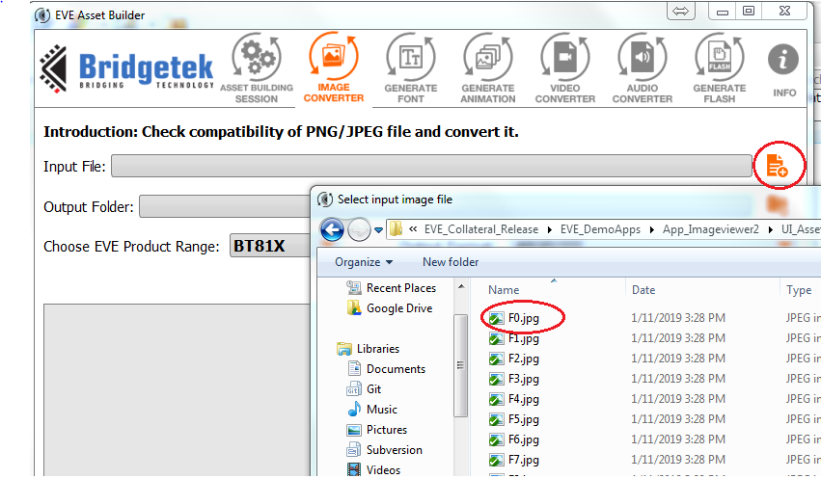

Figure 2: Select input file

* Select output folder, Output format as ASTC 4x4 and the compression speed:

*The “Compressed” radio button should be uncheck

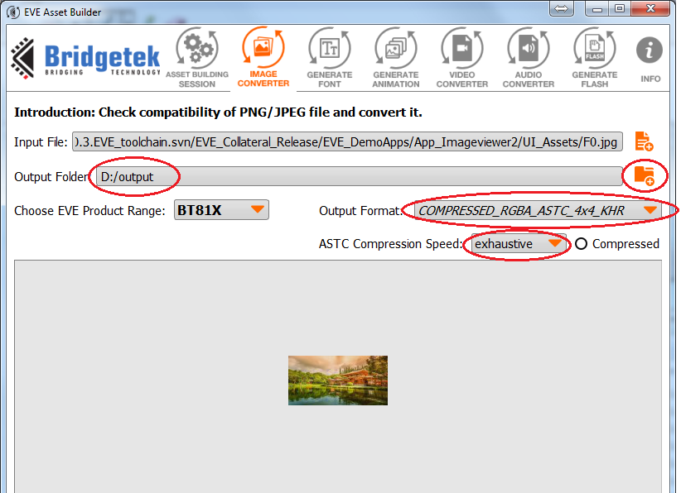

Figure 3: Select output

* Press “Convert” button to start convert image:

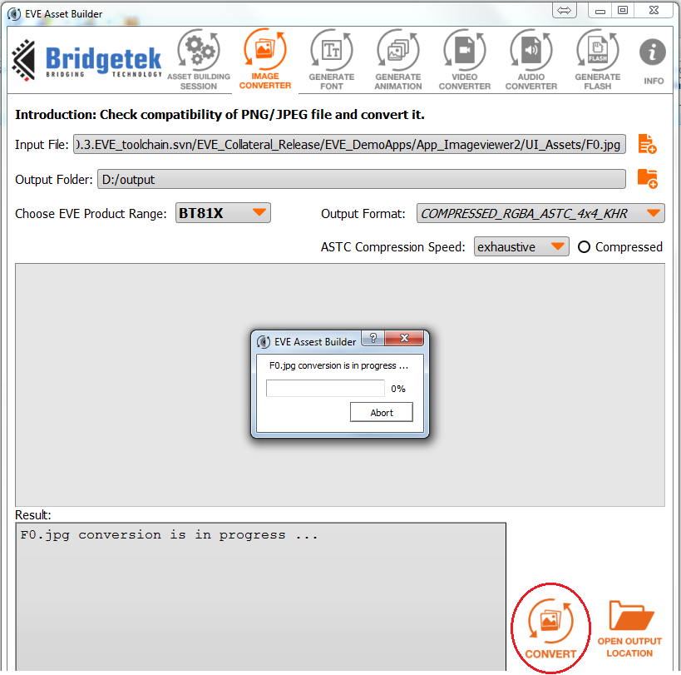

Figure 4: Start convert image

* The Jpeg images are converted into raw file, repeat for other input:

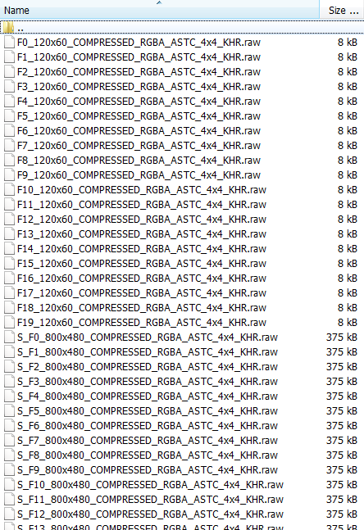

Figure 5: Converted images

### Generate flash image with converted images

This step combine all the raw file into one flash file. The steps are described as below:

* Start EAB tool and select tab “Generate Flash:

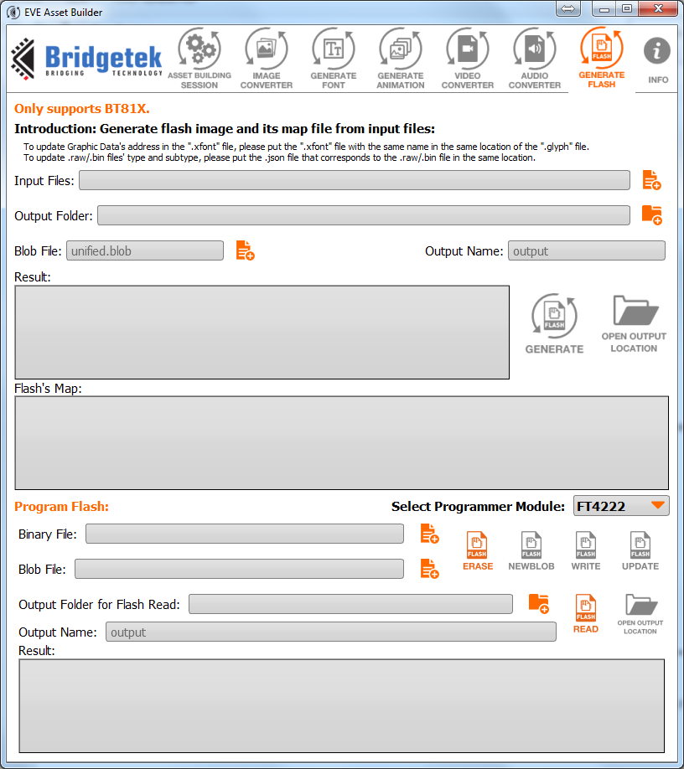

Figure 6: Generate flash tab

* Select raw files in the previous steps as the input, select output and type the flash’s file name in the “Output name”, then press “Generate”:

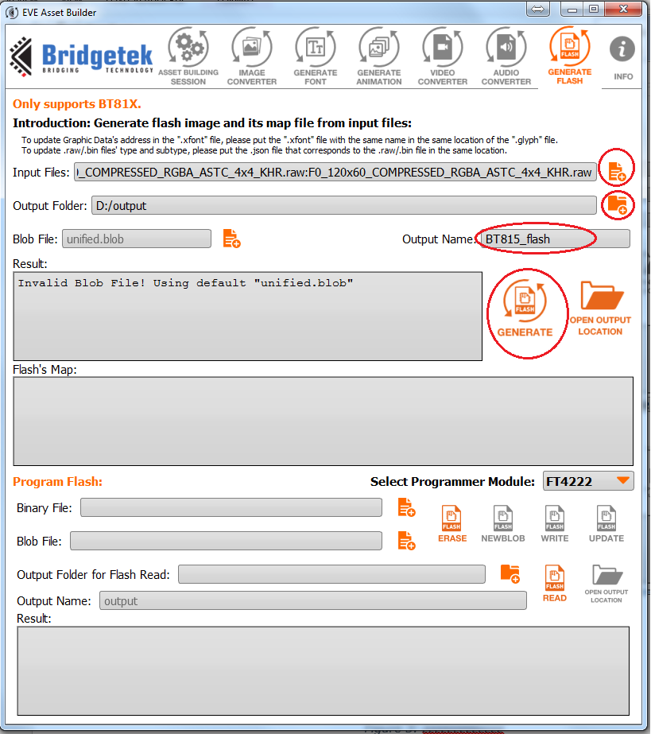

Figure 7: Setting for flash generation

* Generating screen:

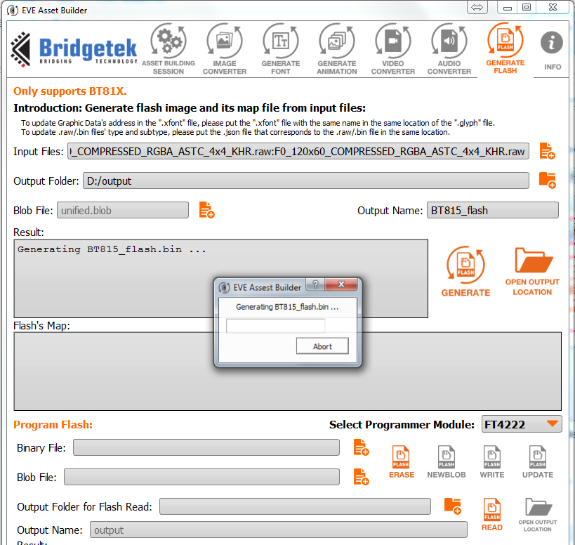

Figure 8: Generating screen

* After generated, Flash’s map is appear:

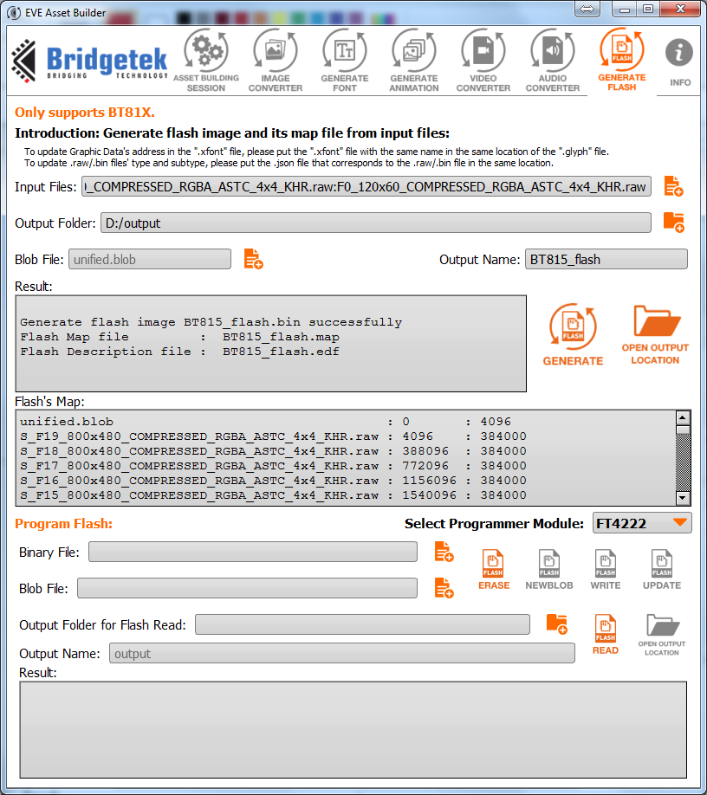

Figure 9: Generate flash done

* The flash image is put into output folder with extension .bin:

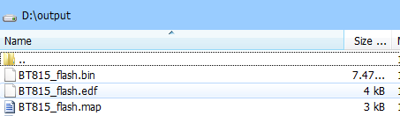

Figure 10: Output folder

* The map file contains the address and size of raw files:

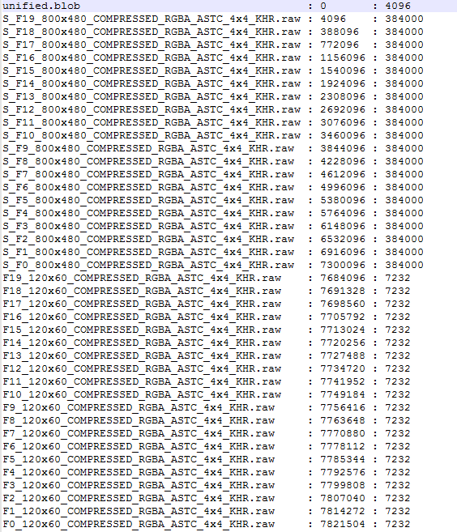

Figure 11: Content of the map file

## Store the generated flash image inside flash memory on EVE platform

* Select programmer module, binary file is the generated *.bin file, the press update:

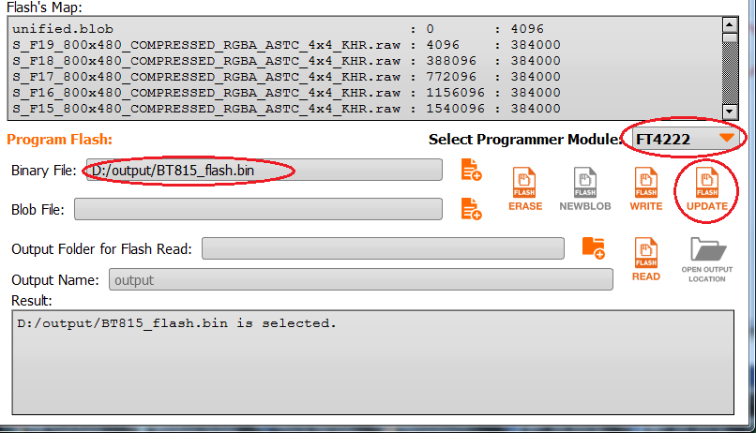

Figure 12: Update flash image

## Display images using generated flash image

* The sample code is generated into output folder too:

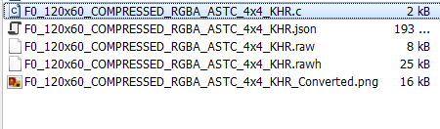

Figure 13: sample source file

* Follow the sample code to display the image:

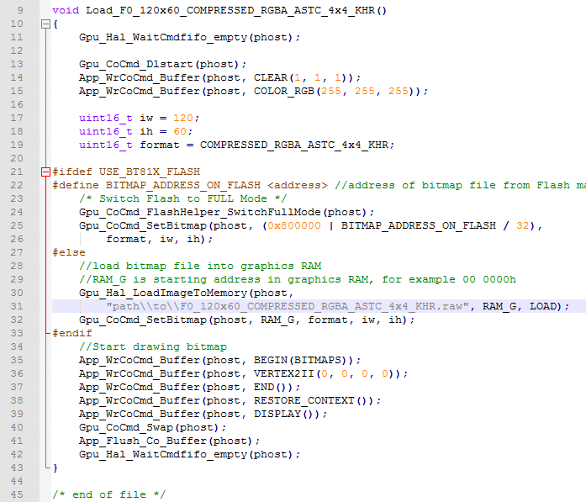

Figure 14: Sample code to display image

# Contact Information

|  |  |  |  |
| --- | --- | --- | --- |
| **Head Quarters – Singapore** | | **Branch Office – Taipei, Taiwan** | |
|  | |  | |
| Bridgetek Pte Ltd  178 Paya Lebar Road, #07-03  Singapore 409030  Tel: +65 6547 4827  Fax: +65 6841 6071 | | Bridgetek Pte Ltd, Taiwan Branch  2 Floor, No. 516, Sec. 1, Nei Hu Road, Nei Hu District  Taipei 114  Taiwan , R.O.C.  Tel: +886 (2) 8797 5691  Fax: +886 (2) 8751 9737 | |
|  | |  | |
| E-mail (Sales) | [sales.apac@brtchip.com](mailto:sales.apac@brtchip.com) | E-mail (Sales) | [sales.apac@brtchip.com](mailto:sales.apac@brtchip.com) |
| E-mail (Support) | [support.apac@brtchip.com](mailto:support.apac@brtchip.com) | E-mail (Support) | [support.apac@brtchip.com](mailto:support.apac@brtchip.com) |

|  |  |  |  |
| --- | --- | --- | --- |
| **Branch Office - Glasgow, United Kingdom** | | **Branch Office – Vietnam** | |
|  | |  | |
| Bridgetek Pte. Ltd.  Unit 1, 2 Seaward Place, Centurion Business Park  Glasgow G41 1HH  United Kingdom  Tel: +44 (0) 141 429 2777  Fax: +44 (0) 141 429 2758 | | Bridgetek VietNam Company Limited  Lutaco Tower Building, 5th Floor, 173A Nguyen Van Troi, Ward 11, Phu Nhuan District, Ho Chi Minh City, Vietnam  Tel : 08 38453222 Fax : 08 38455222 | |
|  | |  | |
| E-mail (Sales) | [sales.emea@brtichip.com](mailto:sales.emea@brtichip.com) | E-mail (Sales) | [sales.apac@brtchip.com](mailto:sales.apac@brtchip.com) |
| E-mail (Support) | [support.emea@brtchip.com](mailto:support.emea@brtchip.com) | E-mail (Support) | [support.apac@brtchip.com](mailto:support.apac@brtchip.com) |

**Web Site**

<http://brtchip.com/>

**Distributor and Sales Representatives**

Please visit the Sales Network page of the [Bridgetek Web site](http://brtchip.com/contact-us/) for the contact details of our distributor(s) and sales representative(s) in your country.

System and equipment manufacturers and designers are responsible to ensure that their systems, and any Bridgetek Pte Ltd (BRTChip) devices incorporated in their systems, meet all applicable safety, regulatory and system-level performance requirements. All application-related information in this document (including application descriptions, suggested Bridgetek devices and other materials) is provided for reference only. While Bridgetek has taken care to assure it is accurate, this information is subject to customer confirmation, and Bridgetek disclaims all liability for system designs and for any applications assistance provided by Bridgetek. Use of Bridgetek devices in life support and/or safety applications is entirely at the user’s risk, and the user agrees to defend, indemnify and hold harmless Bridgetek from any and all damages, claims, suits or expense resulting from such use. This document is subject to change without notice. No freedom to use patents or other intellectual property rights is implied by the publication of this document. Neither the whole nor any part of the information contained in, or the product described in this document, may be adapted or reproduced in any material or electronic form without the prior written consent of the copyright holder. Bridgetek Pte Ltd, 178 Paya Lebar Road, #07-03, Singapore 409030. Singapore Registered Company Number: 201542387H.

# Appendix A– References

## Document References

* [AN_391 EVE Platform Guide](http://brtchip.com/wp-content/uploads/Support/Documentation/Application_Notes/ICs/EVE/AN_391-EVE-Platform-Guide.pdf)
* [BT8XX Series Programmer Guide](http://brtchip.com/programming-guide/)
* [BT815/6 Embedded Video Engine Datasheet](http://brtchip.com/wp-content/uploads/Support/Documentation/Datasheets/ICs/EVE/DS_BT815_6.pdf)

## Acronyms and Abbreviations

|  |  |
| --- | --- |
| **Terms** | **Description** |
| EVE | Embedded Video Engine |
| MSVC | Microsoft Visual Studio C++ |
| SPI | Serial Peripheral Interface |
| UI | User Interface |
| HAL | Hardware Abstraction Layer |

# Appendix B – List of Tables & Figures

## Table of Figures

Figure 1: Start EAB tool and select tab “Image converter” 5

Figure 2: Select input file 6

Figure 3: Select output 6

Figure 4: Start convert image 7

Figure 5: Converted images 8

Figure 6: Generate flash tab 9

Figure 7: Setting for flash generation 10

Figure 8: Generating screen 11

Figure 9: Generate flash done 12

Figure 10: Output folder 12

Figure 11: Content of the map file 13

Figure 12: Update flash image 14

Figure 13: sample source file 14

Figure 14: Sample code to display image 15

## Table of Tables

Table 1: Image list 4

# Appendix C– Revision History

Document Title: App_Imageviewer2: How to generate the flash image

Document Reference No.: N/A

Clearance No.:

Product Page: <http://brtchip.com/product/>

Document Feedback: [Send Feedback](mailto:docufeedback@brtchip.com?subject=Document%20Feedback:%20AN_418%20Version%201.0)

|  |  |  |
| --- | --- | --- |
| Revision | Changes | Date |
| 0.1 | Initial release | 2018-08-21 |

|  |  |  |
| --- | --- | --- |
|  |  |  |
|  |  |  |
|  |  |  |
|  |  |  |
|  |  |  |
|  |  |  |

**Revision History**

Revision history (internal use only, please clearly state any changes here before saving the file)

|  |  |  |  |
| --- | --- | --- | --- |
| **Revision** | **Date**  **YYYY-MM-DD** | **Changes** | **Editor** |
| Draft | 2019-01-14 | Created initial draft | Tuan Nguyen |
|  |  |  |  |
|  |  |  |  |
|  |  |  |  |